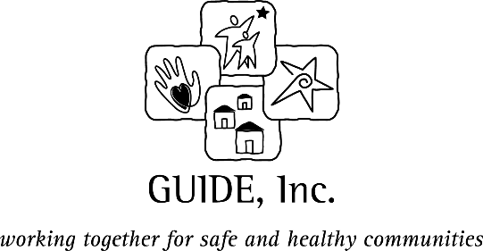

Red Ribbon Week 2021

Photo, Video & Artwork Release Agreement
THIS FORM MUST BE COMPLETED AND SIGNED BY A PARENT/GUARDIAN IF INDIVIDUALS SUBMITTING RRW CONTEST ENTRIES ARE UNDER THE AGE OF 18.

The undersigned give permission for the participant’s contest entry (be it video, photograph or writing) to be used by GUIDE, Inc. for the purposes of publication and promotion. The undersigned give permission for participant’s submission to be photographed, videotaped and/or quoted. The undersigned hereby consent to and authorize the use by the Releasees of the participant’s image and/or likeness and participant’s entry and/or likeness for any promotional purposes. The undersigned waive the right to inspect or approve the participant’s image, entry or any finished materials that incorporate the participant’s image or entry and understands and agrees that any such image or entry will become part of the Releasees’ file and that it may be distributed to other organizations or individuals for use in publication. The undersigned also understand that they will receive no compensation in connection with the use of the participant’s image or entry outside of the contest.

The undersigned further expressly agree that the foregoing release, waiver and indemnity agreement is intended to be as broad and inclusive as is permitted by the law of the state of Georgia and that if any portion thereof is held invalid, it is agreed that the balance shall, notwithstanding, continue in full legal force and effect.

The undersigned parent or guardian certifies that he/she is the parent/legal guardian of the participant.

This waiver, release and indemnification is given freely and voluntarily by the undersigned without coercion, duress, threat or promise of any kind.

EACH OF THE UNDERSIGNED HAVE READ THE ABOVE WAIVER, RELEASE AND INDEMNIFICATION AGREEMENT:

_________________________________________________ ___________________________
Printed Name of Participant Date

_________________________________________________ ___________________________
Signature of Participant Date

_________________________________________________ ___________________________
Signature of Parent/Guardian (if under 18) Date

This release must be submitted with each contest entry.
Details about the contest can be found at guideinc.org/redribbonweek.

